Hochschule Rhein-Waal

Rhine-Waal University of Applied Sciences

Faculty of Communication and Environment

Prof. [Rolf Becker](https://moodle.hochschule-rhein-waal.de/user/view.php?id=524&course=1)

**Final Assignment**

Project Report

Winter Term 2019/2020

[M-IE_2.02 Geoinformatics](https://moodle.hochschule-rhein-waal.de/course/view.php?id=10688)

By

Francisco Susana (26574)

Erick Rea Reasco (26525)

Submission Date:

25th February 2019

Abstract

[Start writing here]

Table of contents

Introduction **2**

Material and methods **2**

Results **3**

Discussion **3**

Conclusions and Outlook **3**

References **3**

Annex **3**

Statement of authorship **3**

List of figures

List of Tables

# Introduction

The aim of this project is to research

# Material and methods

[Explain how you download the station files and get the stations from NRW]

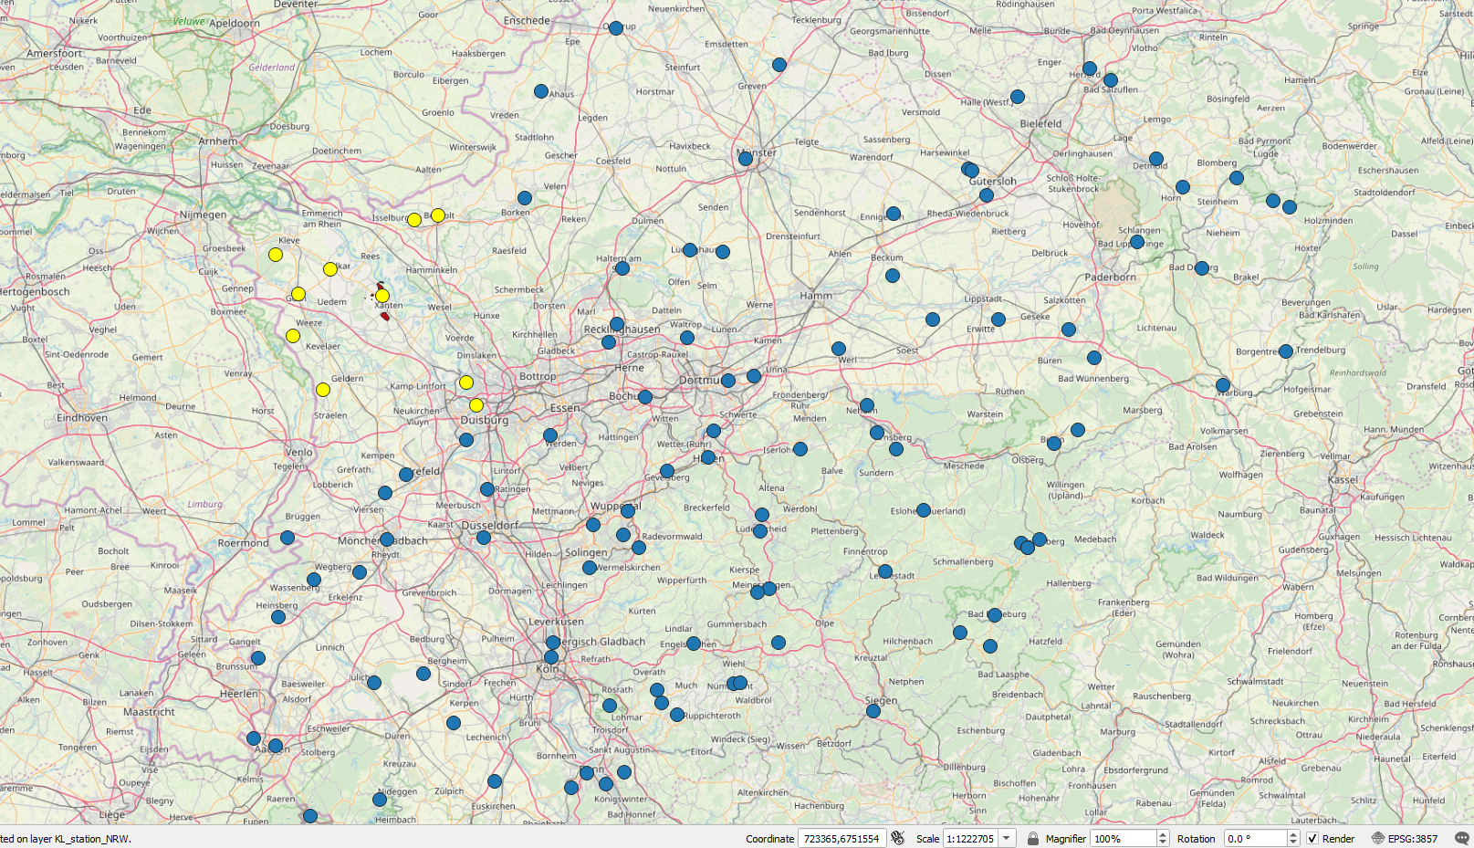

**Figure #**. First block of stations around the ROI area.

Once the [stations_nrw_file].csv file was loaded in QGIS, all the 105 stations from NRW were displayed on the map, then two pre-selections of stations were made: the first one, a block of stations with a radius of 50 kilometers; and second one, a block of stations with a radius of 100 kilometers.

The stations pre-selected were the nearest to the ROI area and with the dates that match the targeted for the analysis.

|  |  |  |  |  |  |  |
| --- | --- | --- | --- | --- | --- | --- |
| **station_id** | **date_from** | **date_to** | **altitude** | **latitude** | **longitude** | **Block** |
| 1303 | 1935-01-01 | 2020-02-18 | 150 | 51.4041 | 6.9677 | 2 (100km) |
| 555 | 1940-01-01 | 2018-11-01 | 101 | 51.4789 | 7.2697 | 2 (100km) |
| 1078 | 1952-01-01 | 2020-02-18 | 37 | 51.296 | 6.7686 | 2 (100km) |
| 13901 | 1979-02-01 | 2020-02-18 | 41 | 51.7343 | 7.1998 | 2 (100km) |
| 617 | 2004-06-01 | 2020-02-18 | 47 | 51.873 | 6.8863 | 2 (100km) |
| 5064 | 2004-12-01 | 2020-02-18 | 37 | 51.2897 | 6.4437 | 2 (100km) |
| 7374 | 2006-03-01 | 2020-02-18 | 46 | 52.0814 | 6.941 | 2 (100km) |
| 13670 | 2007-05-31 | 2020-02-18 | 24 | 51.5088 | 6.7018 | 1 (50km) |
| 3321 | 2008-04-25 | 2020-02-18 | 77 | 51.1313 | 6.3609 | 2 (100km) |

Table #. Pre-selection of stations around the ROI area.

[Check the files from every station to check which one meet the data to analyze]

# Results

[Start writing here]

# Discussion

[Start writing here]

# Conclusions and Outlook

[Start writing here]

# References

[Start writing here]

# Annex

[Start writing here]

# Statement of authorship

*I* ***Francisco*** *hereby declare that my contribution to the work presented herein is my own work completed without the use of any aids other than those listed. Any material from other sources or works done by others has been given due acknowledgment and listed in the reference section. Sentences or parts of sentences quoted literally are marked as quotations; identification of other references regarding the statement and scope of the work is quoted. The work presented herein has not been published or submitted elsewhere for assessment in the same or a similar form. I will retain a copy of this assignment until after the Board of Examiners has published the results, which I will make available on request.”*

*I* ***Erick*** *hereby declare that my contribution to the work presented herein is my own work completed without the use of any aids other than those listed. Any material from other sources or works done by others has been given due acknowledgment and listed in the reference section. Sentences or parts of sentences quoted literally are marked as quotations; identification of other references regarding the statement and scope of the work is quoted. The work presented herein has not been published or submitted elsewhere for assessment in the same or a similar form. I will retain a copy of this assignment until after the Board of Examiners has published the results, which I will make available on request.”*